# **Muhammad Hamza Khan**

## **Assignment: Quiz> Simple Calculator using Static Constructor & Singleton Example**

## **EP#1750044**

## **BSSE-1 Section A**

## **Seat # 22**

### **Submitted to: Miss Raisa Ansari**

#### **Object Oriented Programming**

**Simple Calculator Using Static Constructor**

using System;

using System.Collections.Generic;

using System.Linq;

using System.Text;

using System.Threading.Tasks;

namespace SimpleCalcPrivateConstructor

{

class Program

{

static void Main(string[] args)

{

Calculator Calc = Calculator.CalcPvt;

Console.Write(Calc.total);

Console.ReadKey();

}

}

public class Calculator

{

public float total;

private Calculator()

{

Console.WriteLine("\t\tCalculator");

Console.WriteLine("Enter two number");

Console.Write("Number1>");

float num1 = float.Parse(Console.ReadLine());

Console.Write("Number2>");

float num2 = float.Parse(Console.ReadLine());

Console.WriteLine();

Console.WriteLine("Select Operation");

Console.WriteLine("1.Sum");

Console.WriteLine("2.Subtraction");

Console.WriteLine("3.Multiplication");

Console.WriteLine("4.Division");

Console.Write(">");

double op;

op = int.Parse(Console.ReadLine());

Console.WriteLine();

if (op == 1)

Console.Write("Sum>",total = num1 + num2);

else if (op == 2)

Console.Write("Subtraction>", total = num1 - num2);

else if (op == 3)

Console.Write("Product>", total = num1 * num2);

else if (op == 4)

{

if (num2 != 0)

Console.Write("Division>", total = num1 / num2);

else

Console.Write("Number2 can't be equal to ");

}

else if (op >= 5 || op <= 0)

{

Console.WriteLine("Exiting...");

Console.ReadKey();

Environment.Exit(1);

}

}

public static Calculator CalcPvt = new Calculator();

}

}

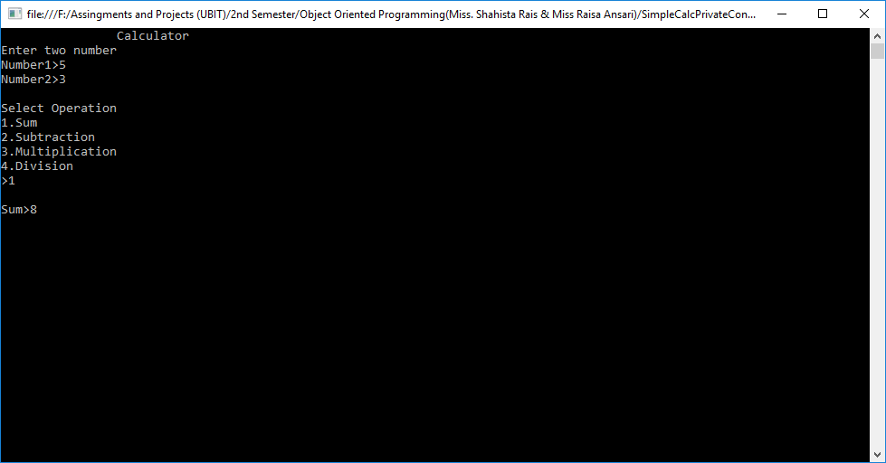

**Next Program:**

**Singleton Example Program.**

using System;

using System.Collections.Generic;

using System.Linq;

using System.Text;

namespace SingleTon_Exampe

{

class Program

{

static void Main(string[] args)

{

Singleton SingletonObject = Singleton.GetObject();

SingletonObject.Print("This is print method called from main method.");

SingletonObject.Print("\nMuhammad Hamza Khan.");

Console.ReadKey();

}

}

public class Singleton

{

protected static Singleton _obj;

private Singleton()

{

Console.WriteLine("This is Private Signleton method.");

}

public static Singleton GetObject()

{

if (_obj == null)

{

_obj = new Singleton();

}

return _obj;

}

public void Print(string s)

{

Console.Write(s);

}

}

}

